**Question 1 Evidence:**



**Question 2 Evidence:**



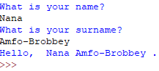**Question 3 Evidence:**

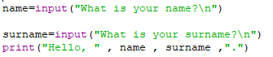

**Question 4 Evidence:**



**Question 5 Evidence:**

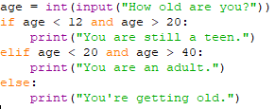

**Question 6 Evidence:**



**Question 7 Evidence:**



**Question 8 Evidence:**



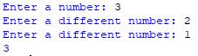**Question 9 Evidence:**

If a was printed

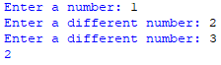****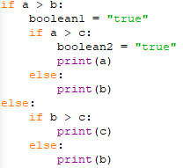

If b was printed

If c was printed